TASK 1:
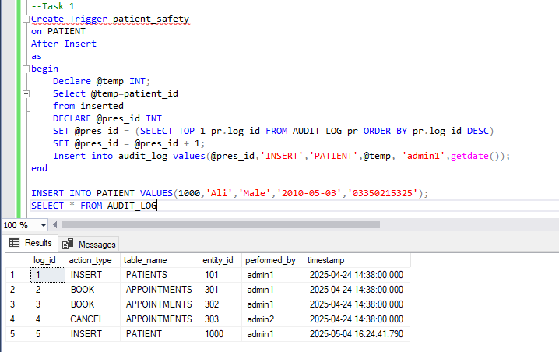
Upon insertion of patient values, Audit Logs following data.

TASK 2:
Upon insertion and deletion, audit logs respective message like “BOOK” on insertion and “ CANCEL” on deletion.

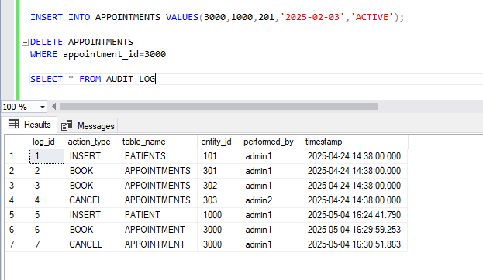
TASK 3:
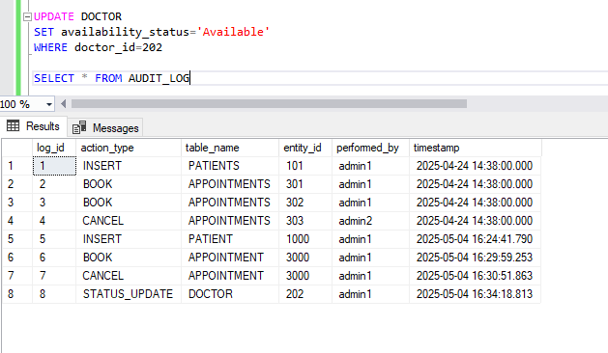
When changing availability from Unavailable to Available, it logs status update data. It would not log if the same status is changed to previous value.

TASK 4:
Upon adding an appointment for an unavailable doctor, it stored the rejected insert record. It will do the same if same appointment is done again with already existing appointment date for a patient.
